

UNIT NAME: ADVANCED WEB DESGIN
UNIT CODE:BIT3208
NAME: MARY WAMBUI
ADM NO: BSCCS/2024/74470
COURSE: BACHELOR OF SCIENCE IN COMPUTER SCIENCE
DEPARTMENT: COMPUTING AND INFORMATICS

LECTURER : MR NYORO
SEMSETER:REGULAR MAY TO AUGUST
SUBMISSION DATE:29\5\2026

GITHUB LINK=github.com/MbuguaMary388/web-development-work/

Contents
LOCAL ENVIRONMENT SETUP 3
4
2:WIREFRAMES AND GUI DESGIN 5
WEEK3:JAVASCRIPT AND PHP BASIS 9
WEEK4:BACKEND FOLDER ORGANISATION. 14
WEEK5:DATABASE OPERATIONS 18
WEEK6:DATABASE INTERGRATION , CRUD OPERATION AND DATABSE NORMALISATION 22
WEEK7:USER AUTHENITICATION AND SESSION MANAGEMENT 26

LOCAL ENVIRONMENT SETUP
The environment in use here is XAMMP.
The installation process involved downloading and installing Apache HTTP Server and MySQL using the XAMPP control panel. After installation, both Apache and MySQL services were started successfully from the XAMPP dashboard. The system was then tested by opening a web browser and accessing http://localhost, which confirmed that the local server was running correctly. In addition, phpMyAdmin was accessed through http://localhost/phpmyadmin to verify that the MySQL database service was functioning properly. This setup provided a local development environment .
It was generally easy to install the Xampp but just a bit confusing on running it.
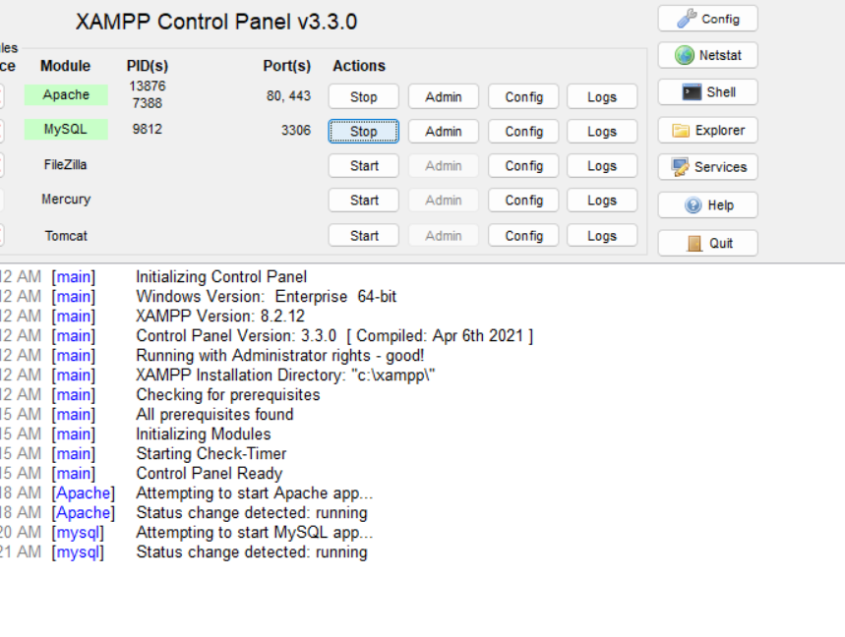

Fig2:localhost test page

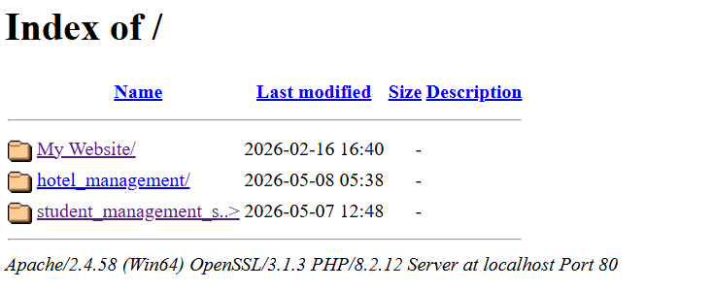

Fig3:hello word test
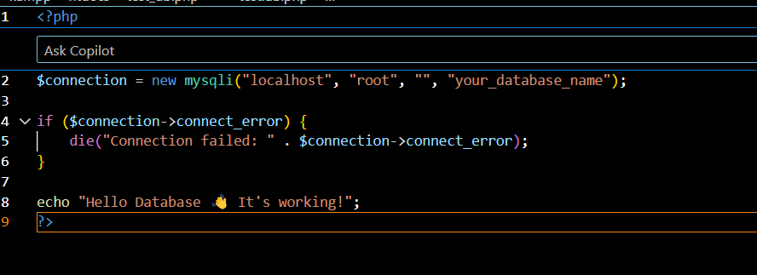
Fig4:Database Connection Test
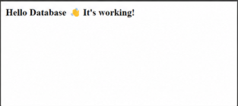

2:WIREFRAMES AND GUI DESGIN
The GUI design activity was successful and educational .The layout interfaces ,mobile layout, navigational structures ,and GUI prototypes were created using Canva. This activity has improved my understanding of user interface design concepts and demonstrated the importance of design interface before implementation .It was a valuable practice and experienced was gained on creating clean interface .
Limitations faced include dependence on the internet which was expensive and limited prior experience with GUI design tools.

Fig1:
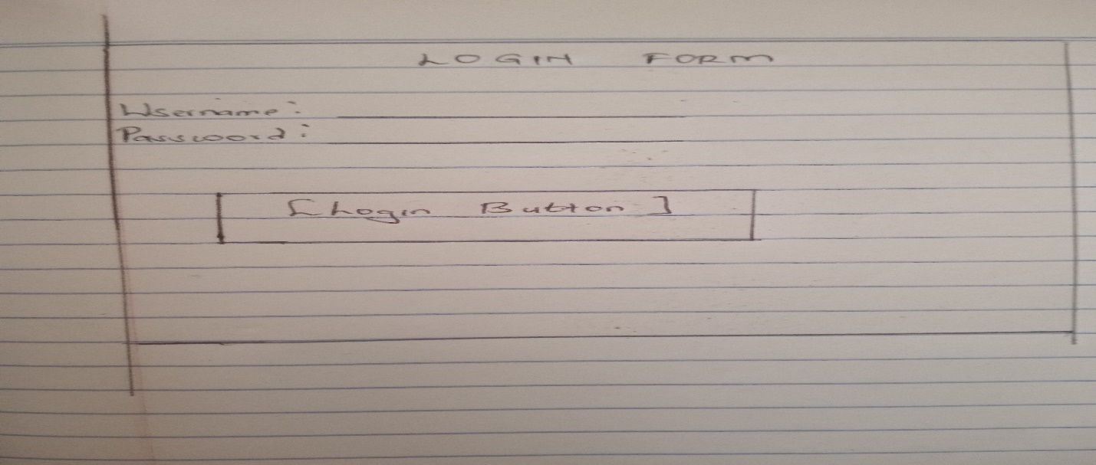

Fig: Dashboard Layout design.
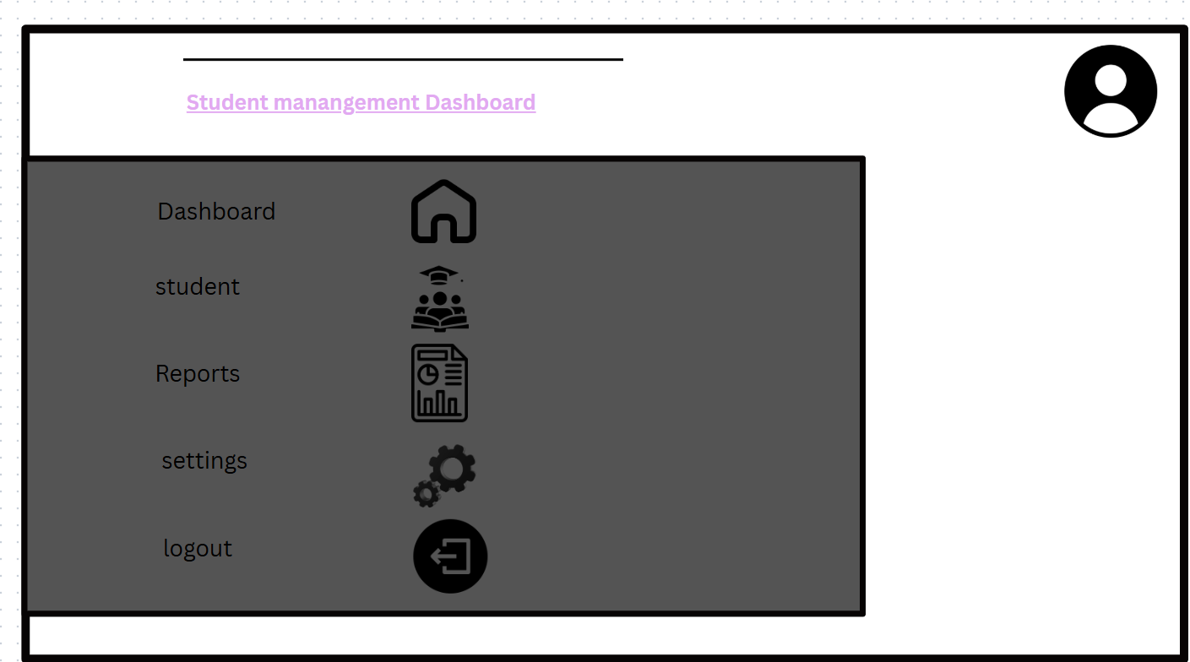

Fig3:Mobile view mockup
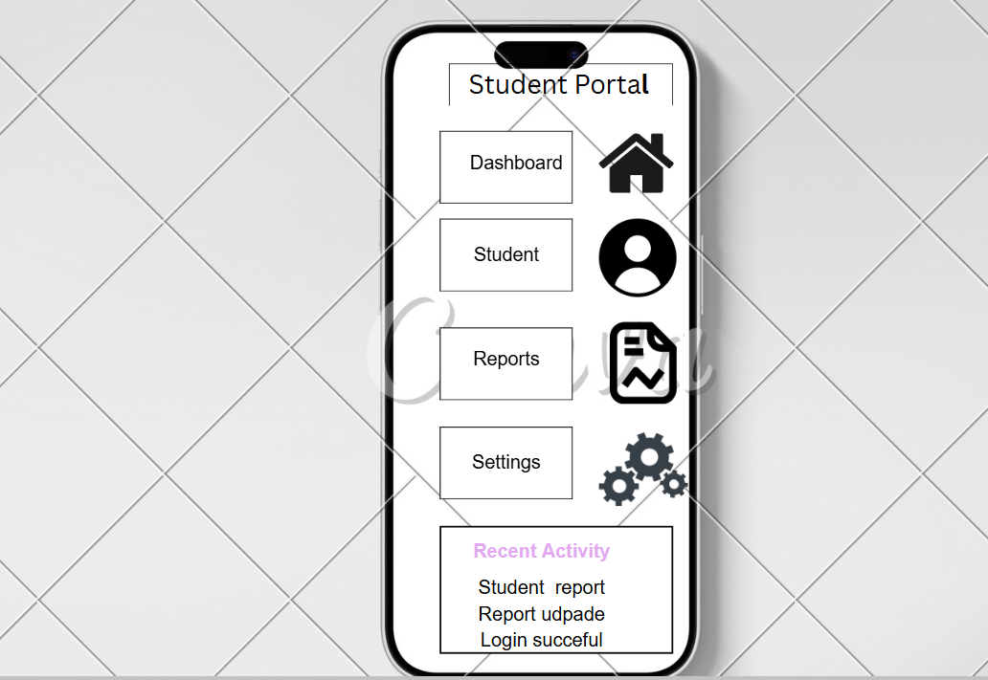

Fig4:Color Theme and 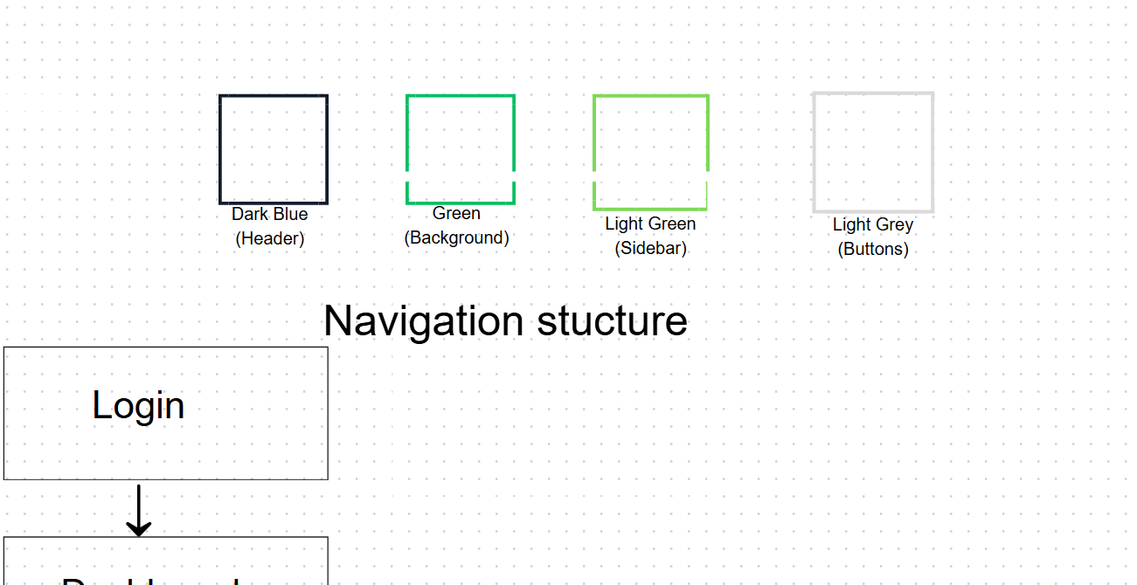Navigation Structure
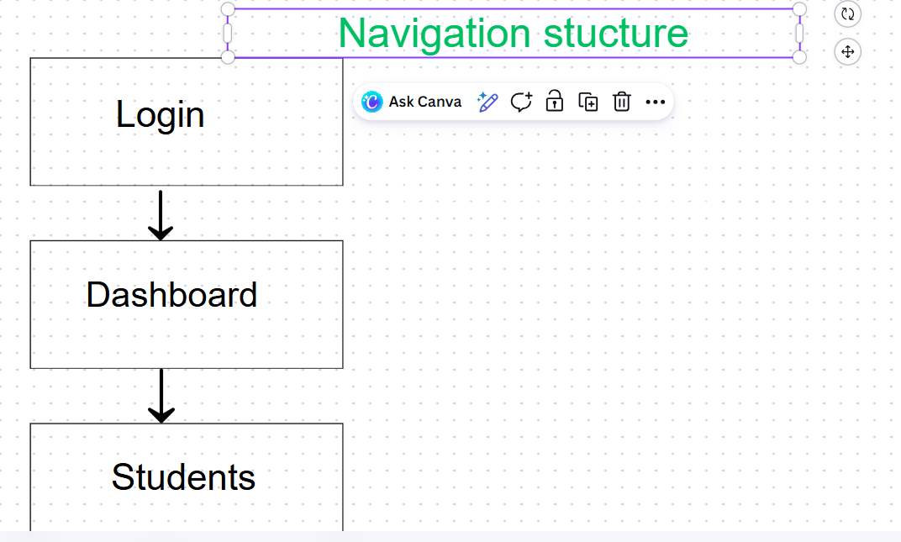

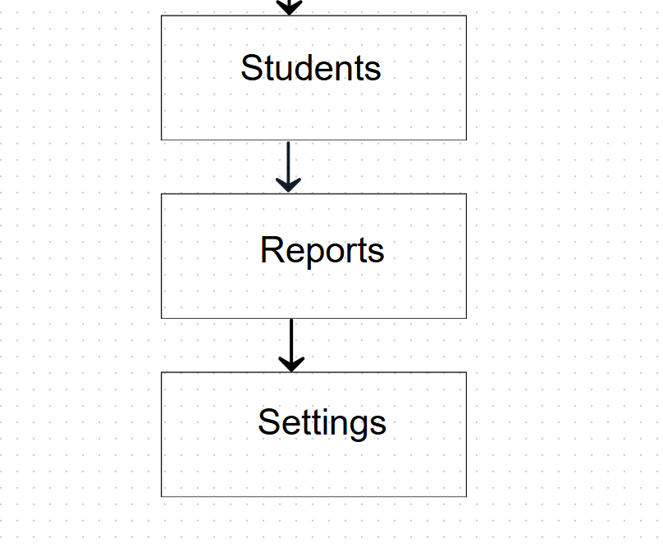

Fig5:GUI prototype in Canva

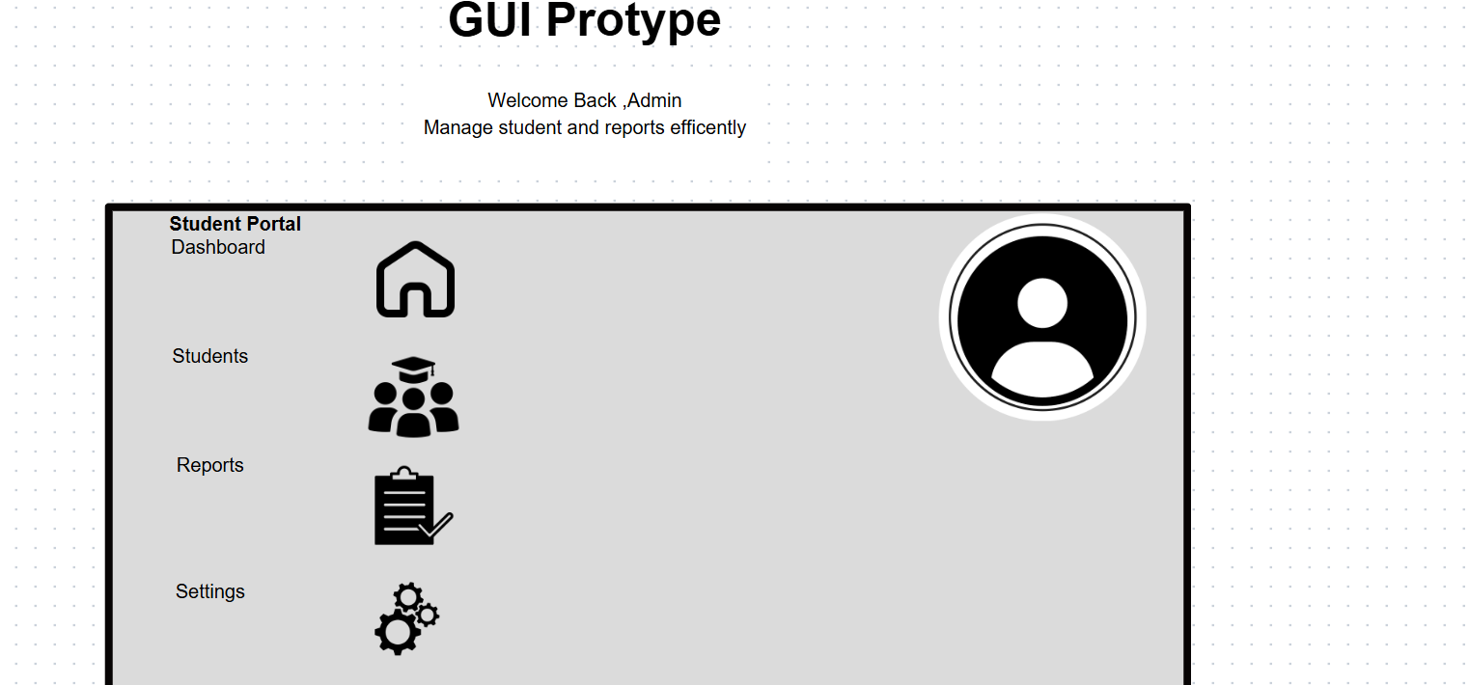

WEEK3:JAVASCRIPT AND PHP BASIS
This practical exercise focused on understanding basic backend development using PHP, including syntax practice, dynamic user input handling, and verifying server functionality using XAMPP localhost environment. The aim was to build foundational skills in web development and under basic PHP scripts were created to understand core syntax such as Output statements using echo ,Variables and data types ,Conditional statements (if-else)
These exercises helped in understanding how PHP executes instructions on the server side before displaying results in the browser.
stand how frontend input interacts with backend processing .

Fig1:JavaScript form validation
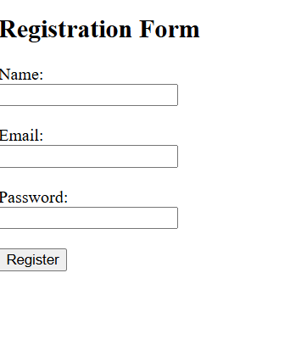
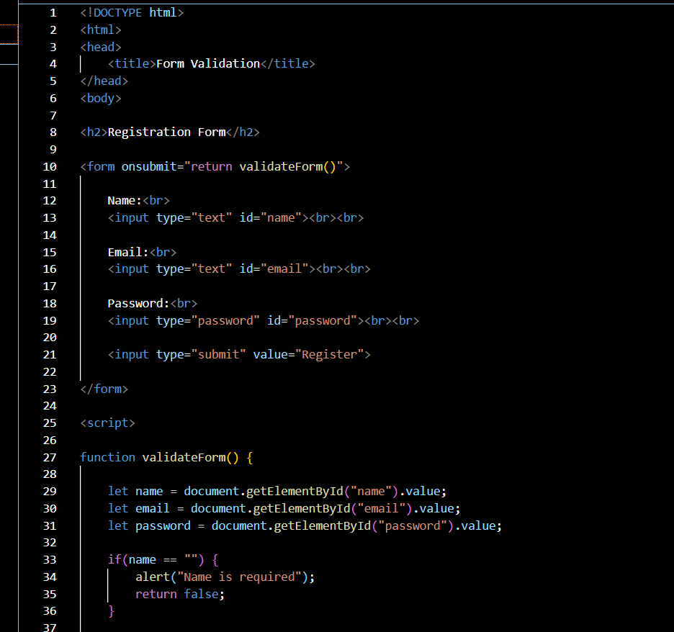

Fig2:Password strength checker
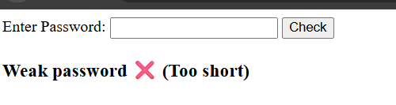
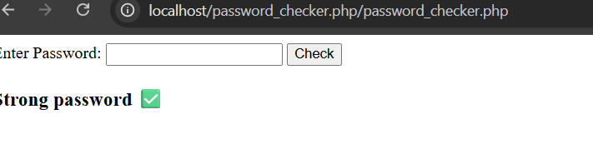

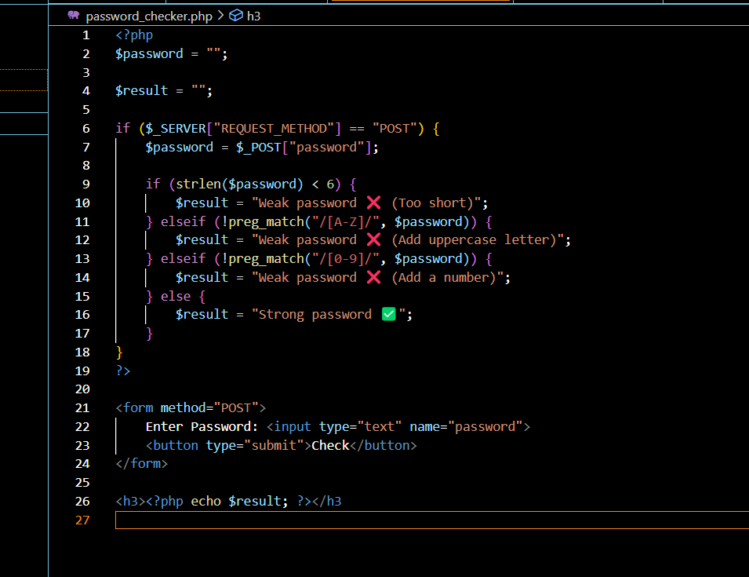
Fig3:PHP syntax practice

IF….statement
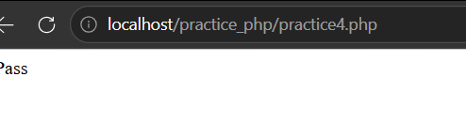
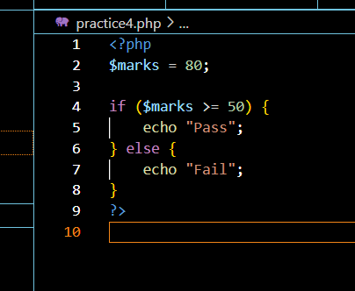
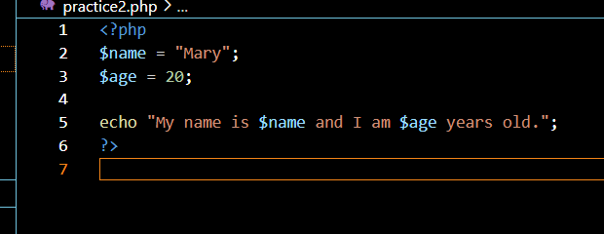
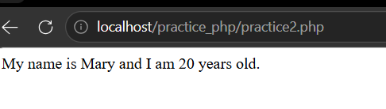
Display hello
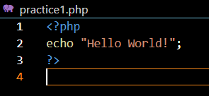
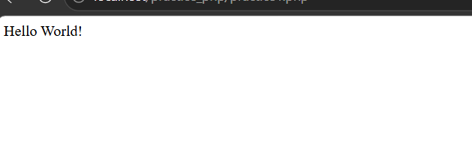
Fig4:Database connection script
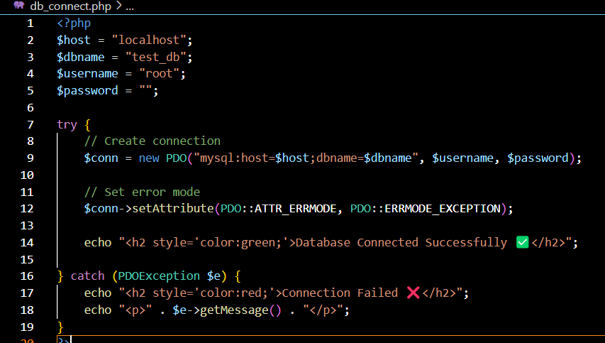

Fig5:Dynamic user input
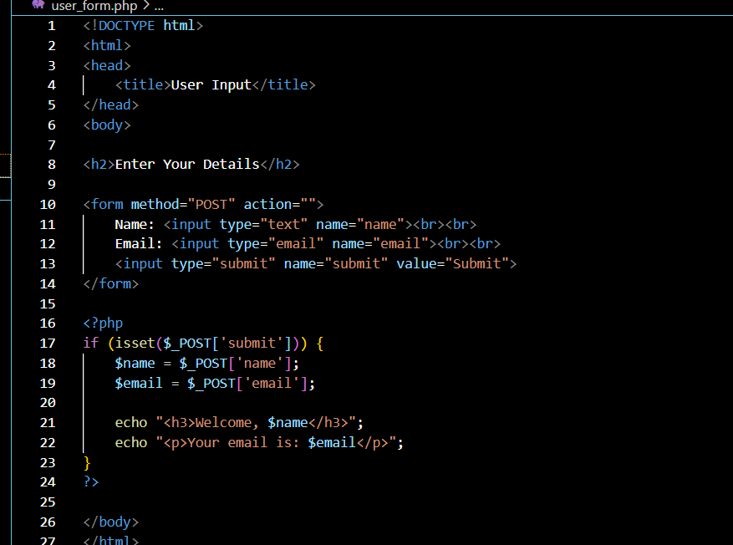
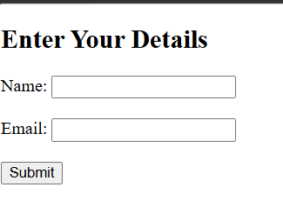
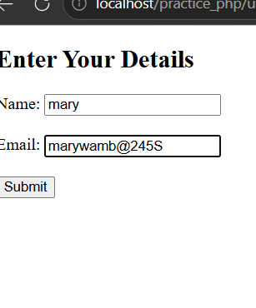
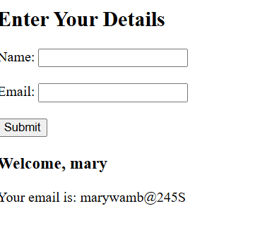

WEEK4:BACKEND FOLDER ORGANISATION.
This project involved developing a simple PHP-based login system with form validation and database connectivity. It included creating a user interface, processing login credentials using PHP, and verifying data from a MySQL database. The system demonstrates basic authentication and server-side processing functionality. It was a bit easy because now I have more knowledge on php.
Fig1:Login screenshots
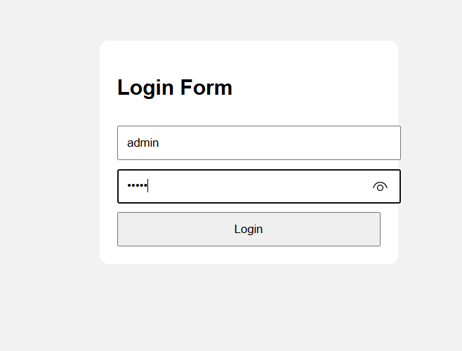
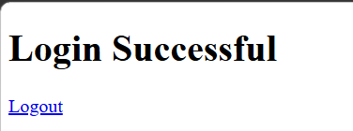
Fig2:form validation 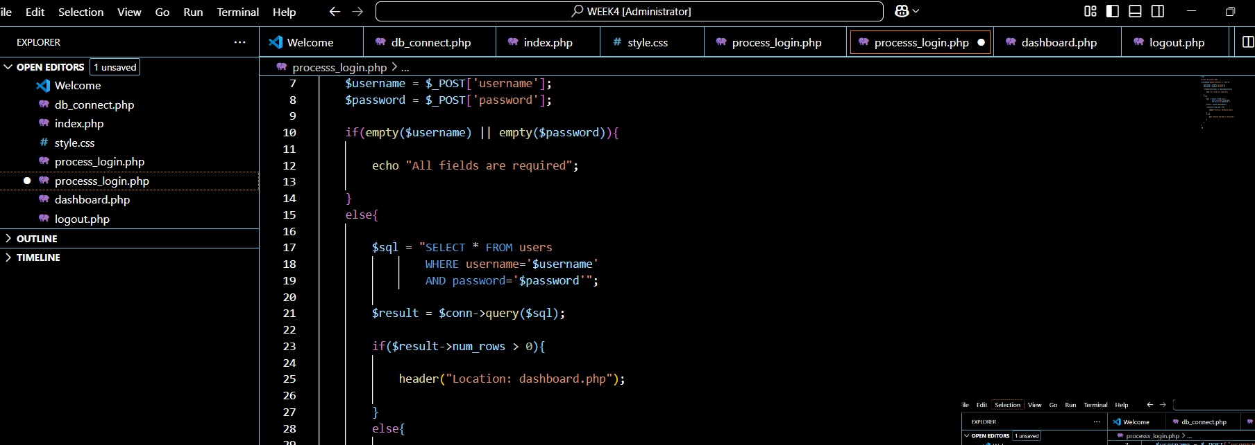
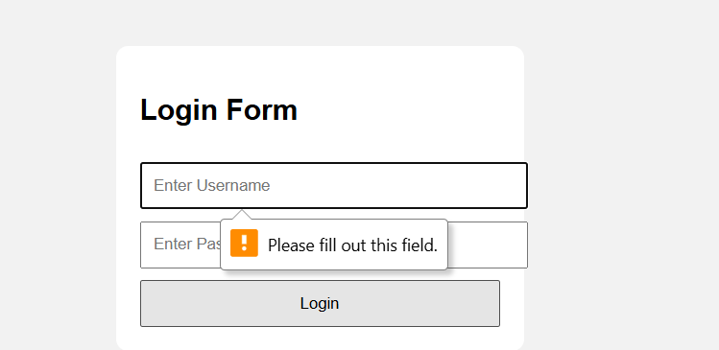
Fig3:PHP processing
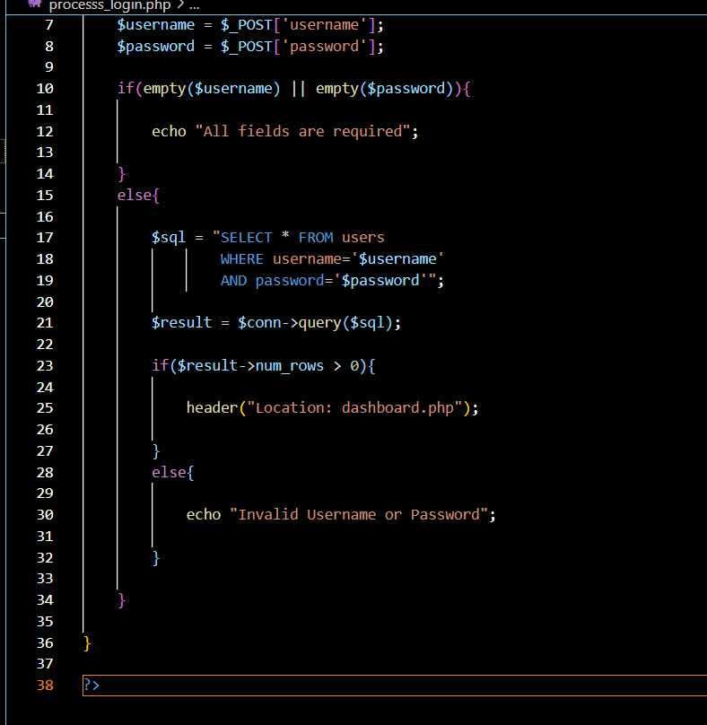
Fig4:Database connection
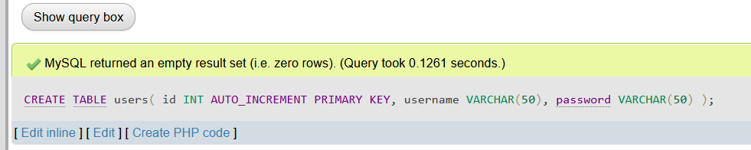
Fig5:Folder structure


WEEK5:DATABASE OPERATIONS
This project implemented a PHP and MySQL system demonstrating CRUD operations and login integration. Users can create, read, update, and delete records in the database. The system also includes secure login authentication, form validation, and database connectivity, showing effective interaction between the frontend, PHP processing, and backend database management.
Fig1:Database screenshots
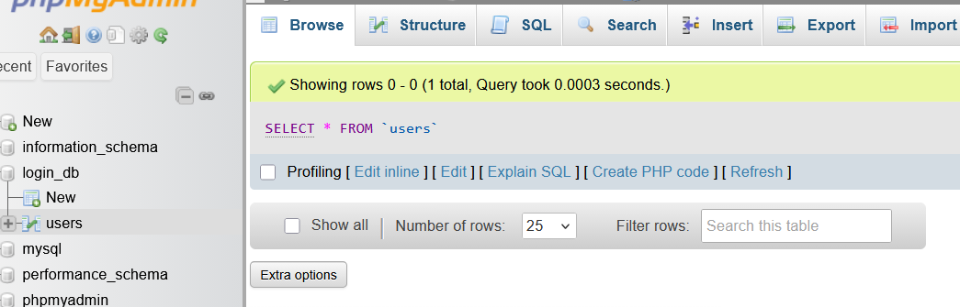
Fig2:Table creation

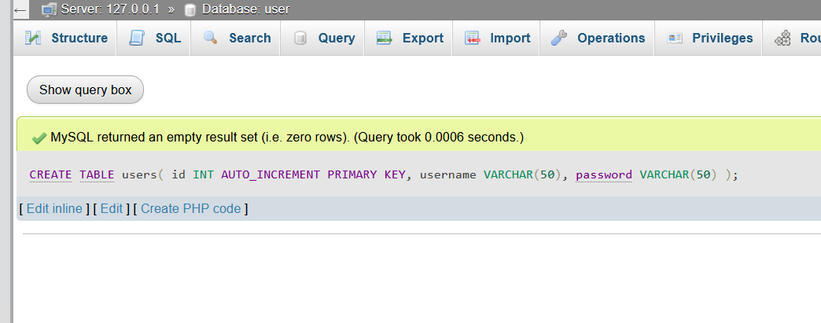
Fig3:CRUD operation
1:Read

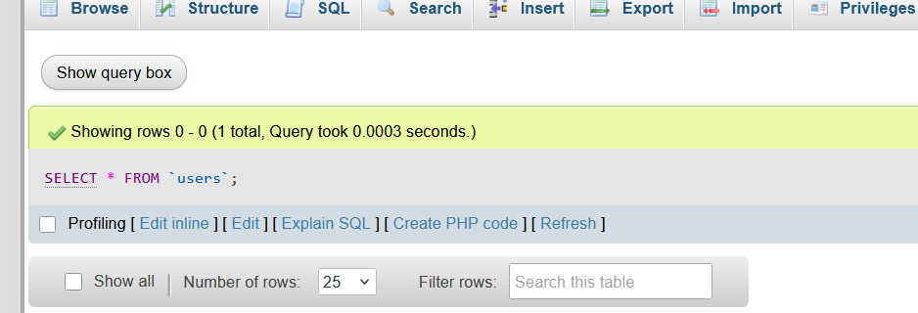
2:update
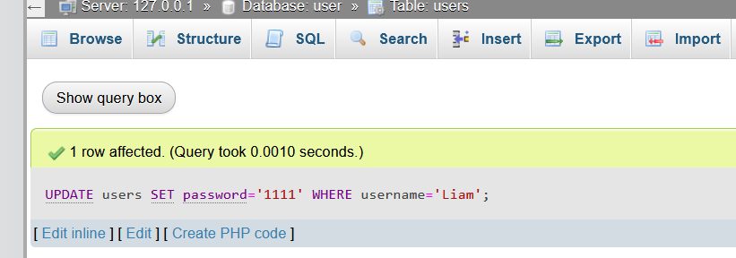

3:Delete
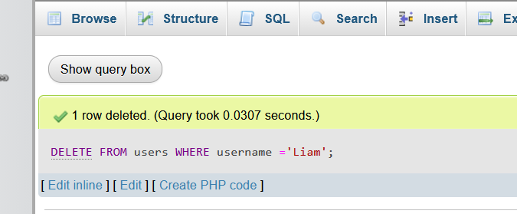
4:Create

Fig4:login database integration



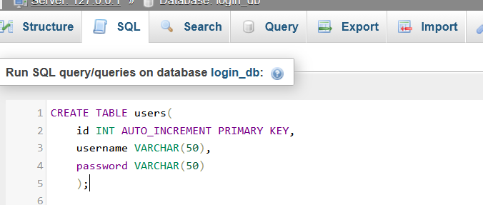
Fig4:SQL query
1:Delete
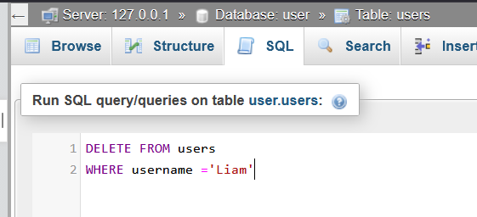
2:Read
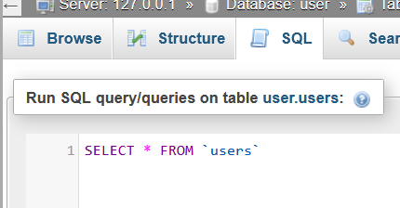
3:Create
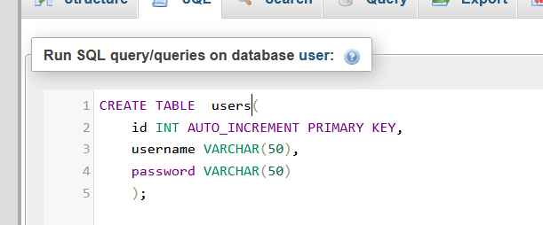
4:Update
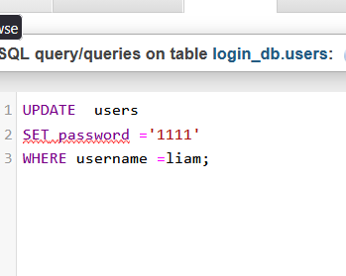

WEEK6:DATABASE INTERGRATION , CRUD OPERATION AND DATABSE NORMALISATION
This week we be dealing with more of database operation like delete, create, delete, read which are very essential and important in every database. Also use of normalization of the database to reduce redundancy and make the database easy to manage , implement and update.
1:create


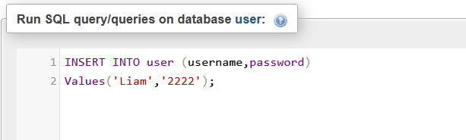
3:Read

4:Update

5:Error display
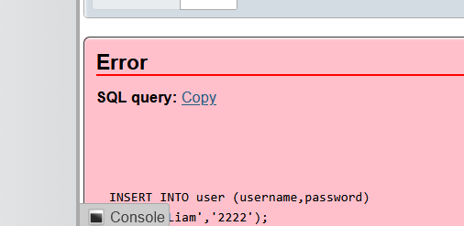

6:Database normalization
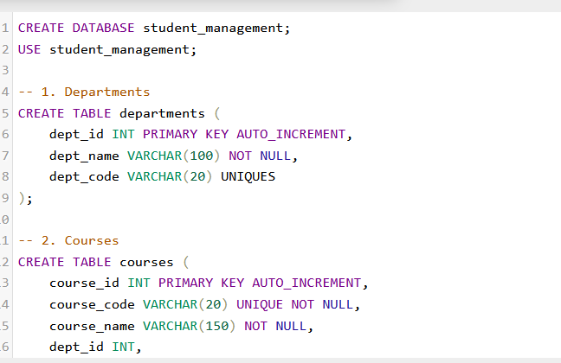
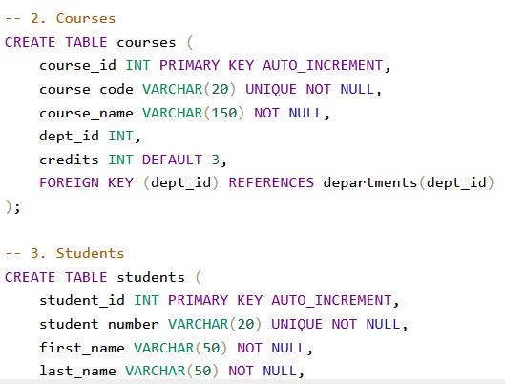
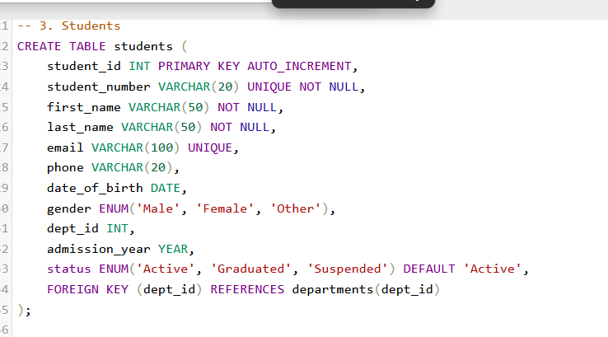
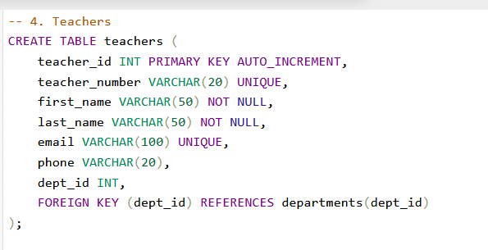
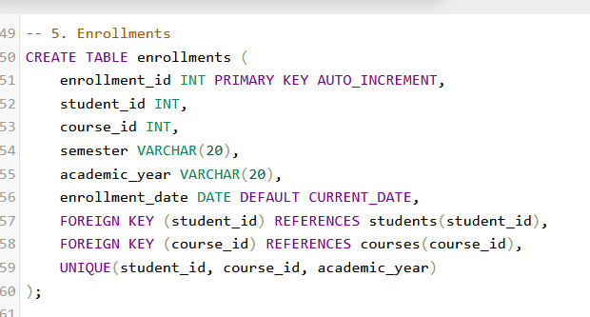
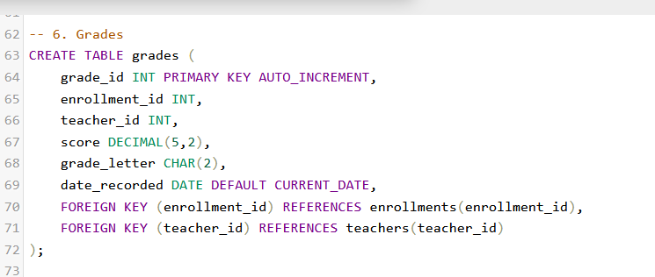
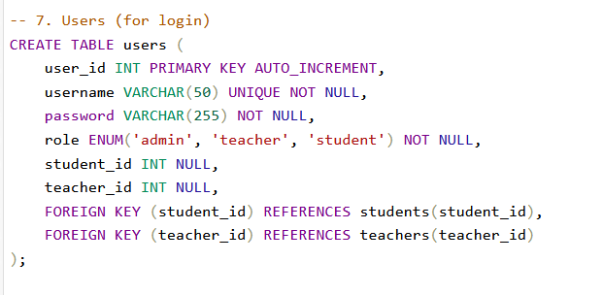
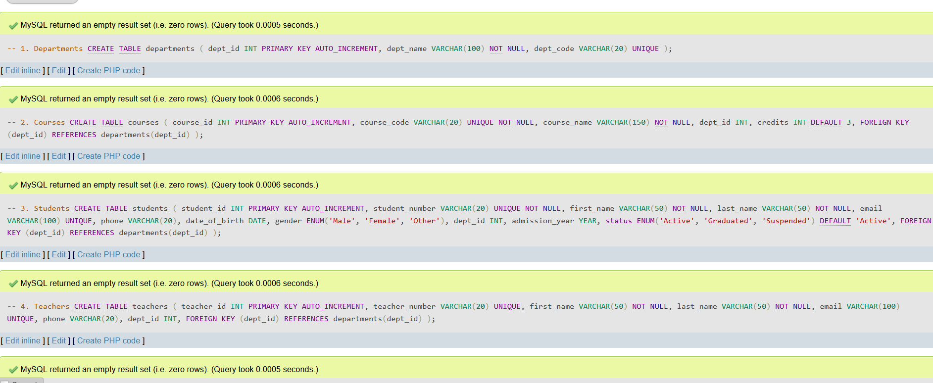
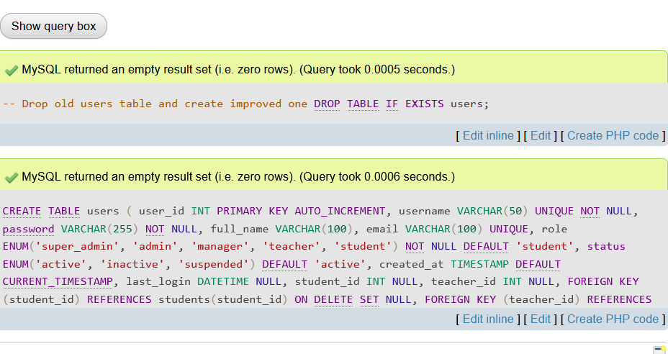

WEEK7:USER AUTHENITICATION AND SESSION MANAGEMENT
On this week the tasks here I learned a lot especially when it comes to implementing the three users : super user rights , the managerial level and the client . Also I learned the need of having authorization and authentication in my systems and also learnt how to implement them. I implemented the use of cookies and sessions and also the benefits of always ensuring that the database hashes the passwords for security.
FIG1:The three users

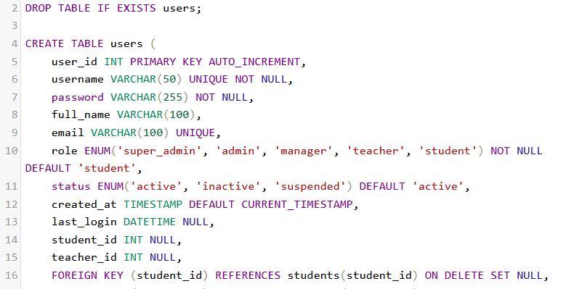

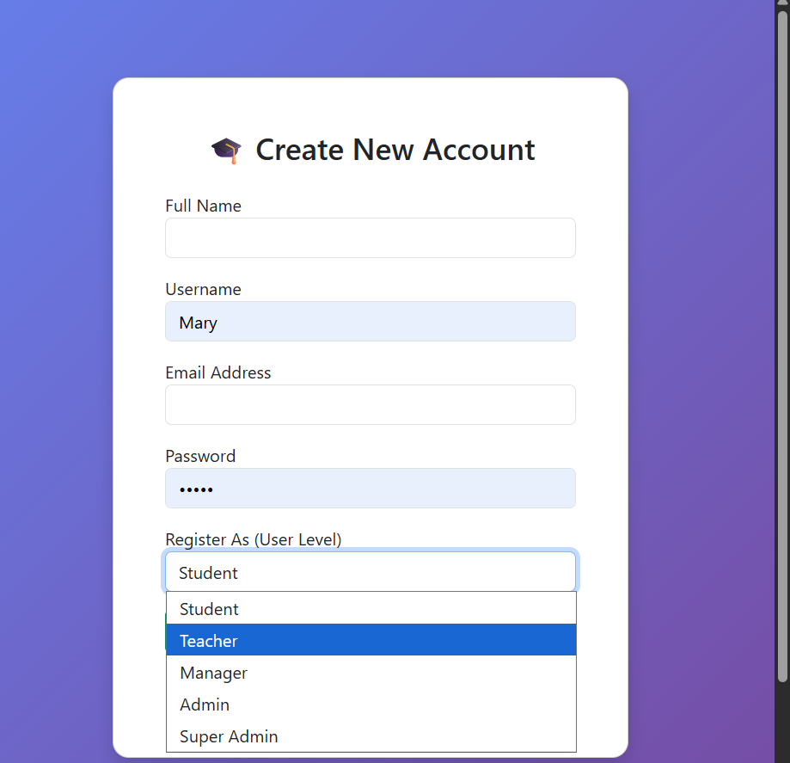

2:Use of cookies and sessions
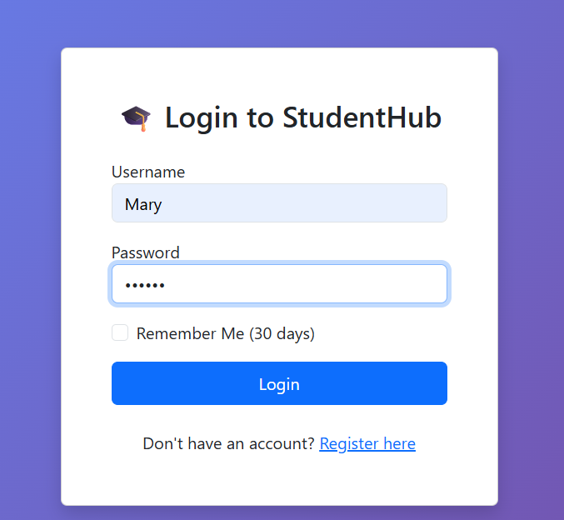

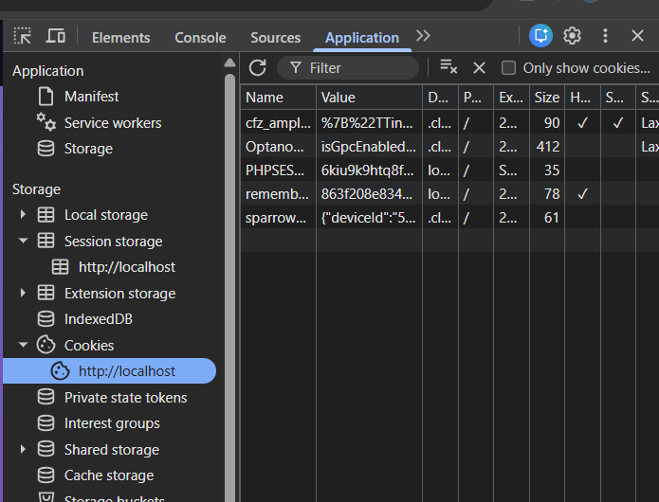

3:User authorization and authentication
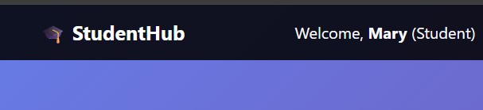
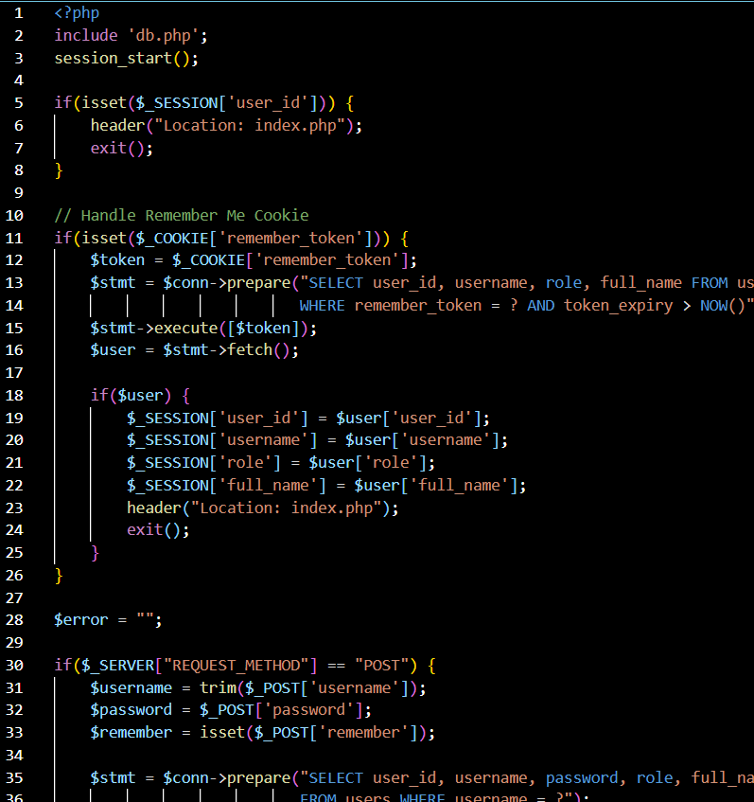
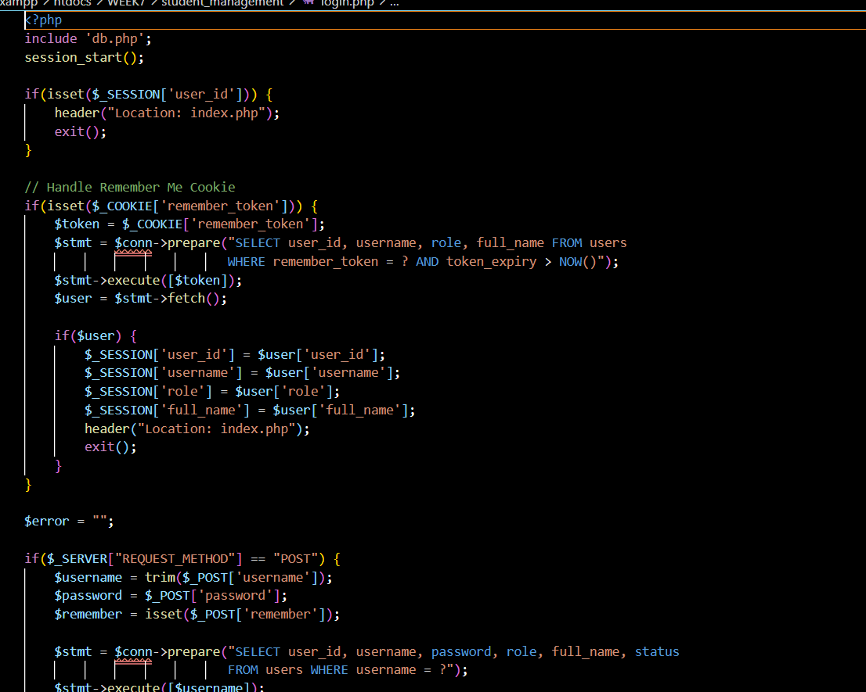

4:HASHING IN DATABASE
